

Student Name : HUBERT M. MULAMA

Admission Number : BBIT/2024/56387

Course : Bachelor of business information technology

Unit Code : BIT3208

Unit Name : Advanced Web Design and Development

Lecturer : MR. NYORO

Year : 3.2

PROJECT DETAILS
Project Title : AuraMart E-Commerce Web Application

Technologies : PHP + MySQL, HTML5, CSS3, JavaScript, XAMPP

GitHub : https://github.com/hubertmulama/auramart

TABLE OF CONTENTS

Week 1 Local Environment Setup 3
1.1 Objective 3
1.2 Evidence 3
1.3 Reflection 4
Week 2 Wireframes and GUI Design 5
2.1 Objective 5
2.2 Evidence 5
2.3 Reflection 6
Week 3 JavaScript and PHP Basics 7
3.1 Objective 7
3.2 Evidence 7
3.3 Reflection 8
Week 4 Server-Side and Authentication 9
4.1 Objective 9
4.2 Evidence 9
4.3 Reflection 10
Week 5 Database CRUD Operations 11
5.1 Objective 11
5.2 Evidence 11
5.3 Reflection 12

WEEK 1: LOCAL ENVIRONMENT SETUP

1.1 Objective
To establish a professional local web development environment capable of running PHP applications and connecting to a MySQL database. This formed the foundation upon which the entire AuraMart e-commerce project would be built.

1.2 Tools and Technologies Used

Tool / Technology | Purpose
XAMPP | Local development server bundling Apache, MySQL, and PHP
Apache | Web server used to serve PHP files locally via localhost
MySQL | Relational database management system for storing project data
phpMyAdmin | Browser-based GUI for creating and managing the MySQL database
VS Code | Source code editor used to write HTML, CSS, PHP, and JavaScript
Google Chrome | Browser used for testing and viewing localhost pages

1.3 Evidence

Figure 1.1: XAMPP installation.
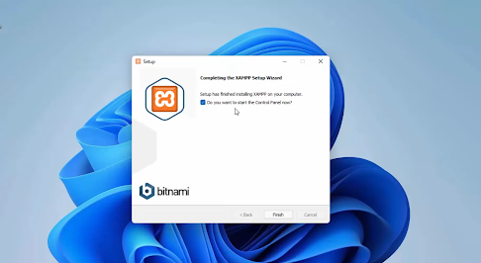

Figure 1.2: XAMPP Control Panel showing Apache and MySQL services active with green status indicators confirming both services are running correctly.
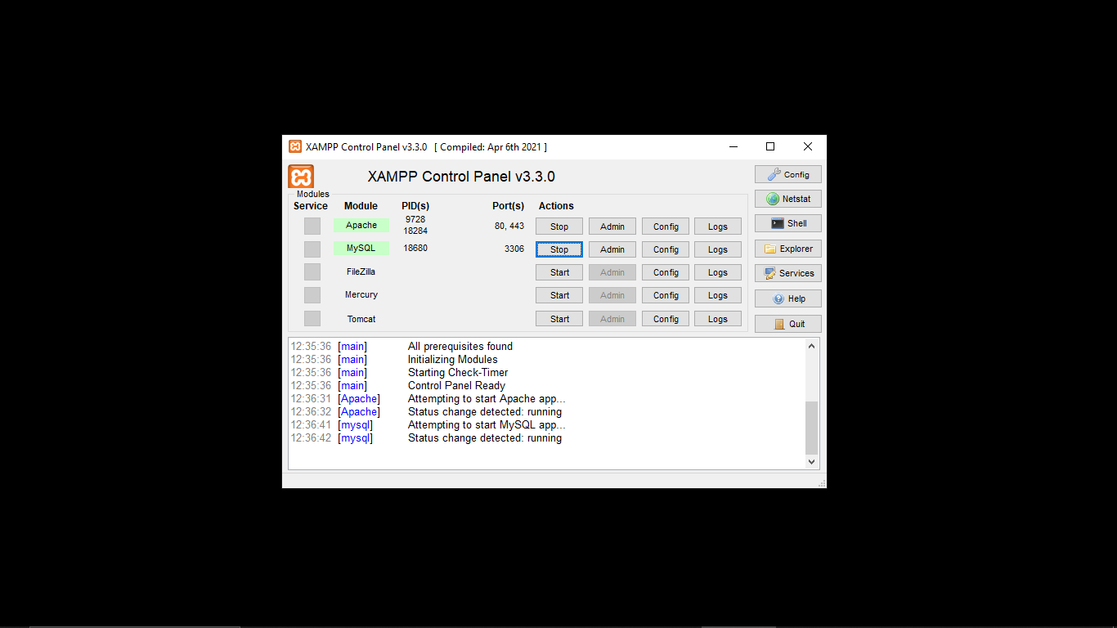
Figure 1.3: Browser displaying the XAMPP default localhost welcome page at http://localhost, confirming that the Apache web server is operational.
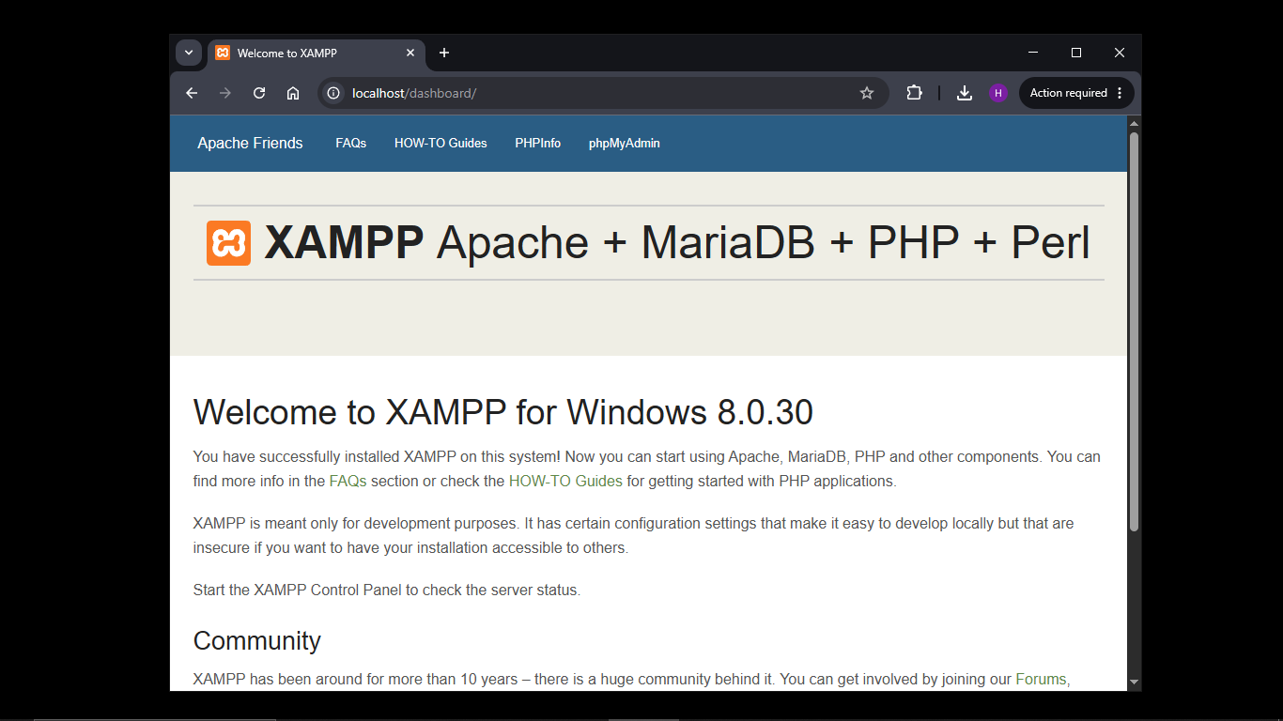
Figure 1.4: Browser displaying the AuraMart Hello World test page at http://localhost/auramart.
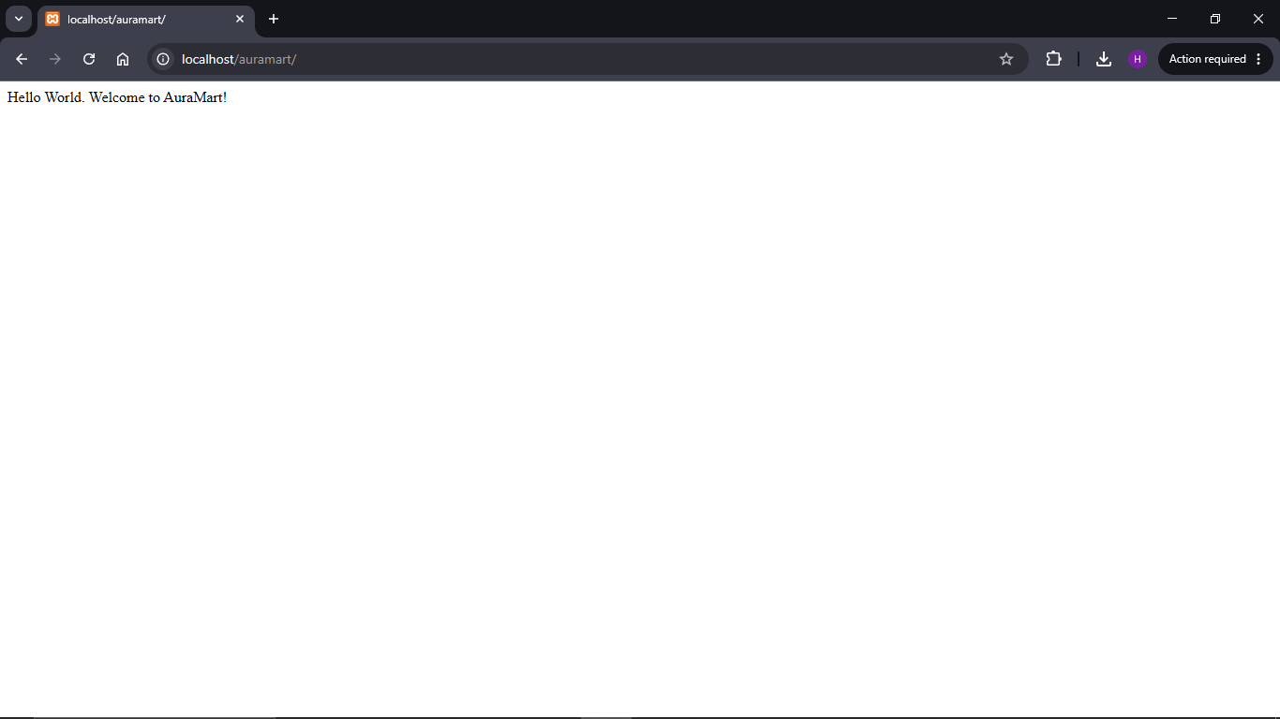

Figure 1.5: phpMyAdmin interface showing the successful creation of the auramart database and the users table structure via the SQL tab.
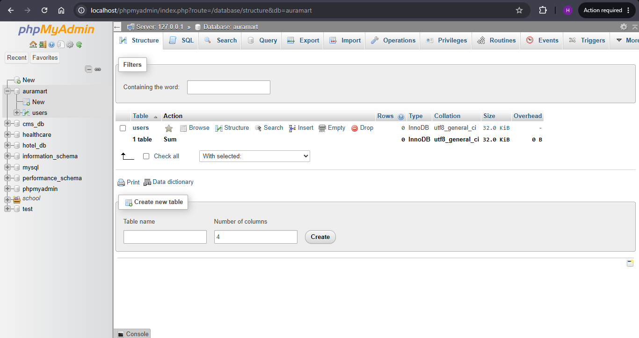

1.4 Objectives Completed

- XAMPP installed and verified on local machine
- Apache and MySQL services confirmed running on the XAMPP Control Panel
- Localhost tested successfully at http://localhost
- AuraMart project folder created at C:\xampp\htdocs\auramart
- PHP Hello World test page created and rendered in browser
- MySQL auramart database created and connection tested via db.php
- Screenshots captured and documented for logbook evidence

1.5 Reflection

I successfully installed XAMPP and configured a local development environment for the AuraMart project. The project folder was created under the htdocs directory, making it accessible via http://localhost/auramart. Their was a successful connection to the MySQL database using PHP, confirming that the server configuration was correct.

WEEK 2: WIREFRAMES AND GUI DESIGN
User Interface Planning and System Design
2.1 Objective
The objective of Week 2 was to plan and design the complete user interface of the AuraMart platform after writing code. This involved creating wireframes, selecting a colour theme, and coming up with the navigation flow for different user roles. Including both admin and customer.

2.2 Summary of design

Design Element | Decision
Project Type | E-Commerce Platform
Primary Colour | Purple as it signifies trust, creativity
Font | Times New Roman as its clean and readable
Navigation | Sticky top navbar to ensure the cart and account access at all scroll positions
Layout | CSS Grid with auto fill columns to ensure responsive product display
Target Users | Customers and Administrators
Pages Designed | Homepage, Login, Register, Cart, Checkout, Customer Dashboard, Admin Panel
Design Tool | Figma used for wireframes

2.3 Evidence

Figure 2.1: Registration page
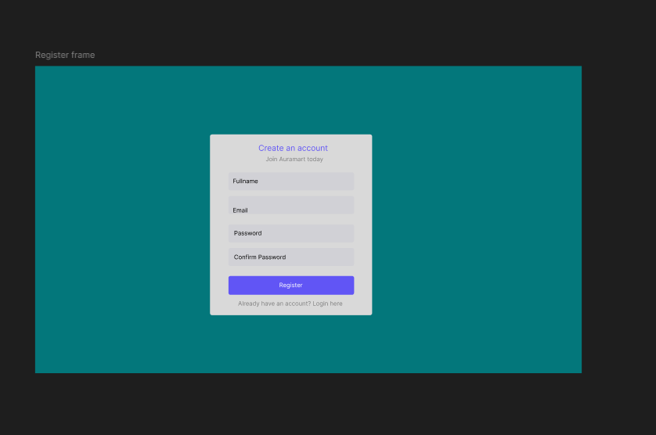

Figure 2.2: Figma login page
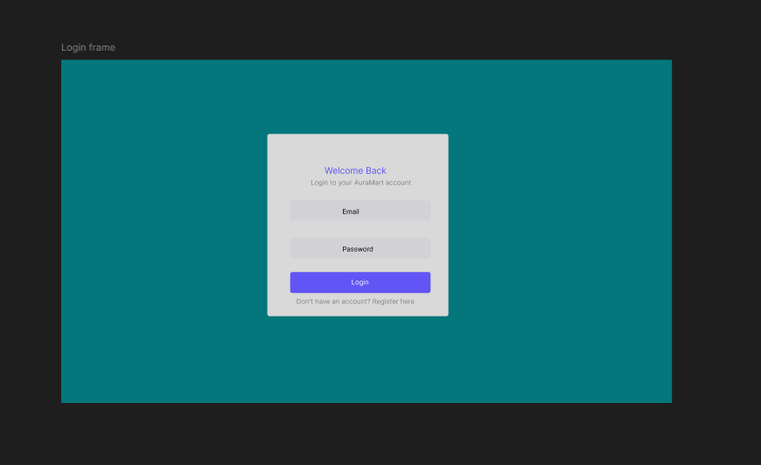

Figure 2.3: Figma homegage
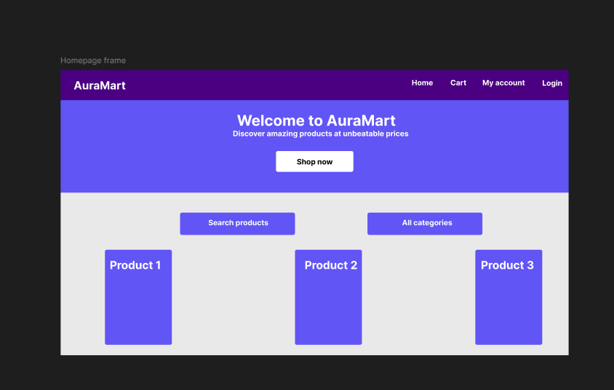

Figure 2.4: Figma customer dashboard
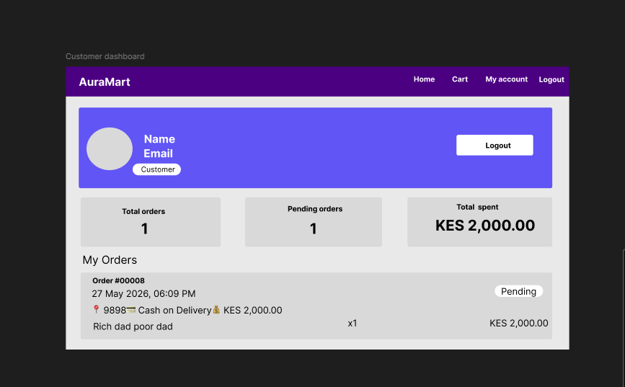
2.4 Objectives Completed

- Hand-drawn wireframe completed for Homepage and Login page
- Figma dashboard layout designed for the customer-facing dashboard
- Mobile responsiveness mockup created for the homepage
- Colour theme and navigation structure
- GUI prototype of the homepage
- Navigation flow mapped for two user roles:customer, and admin

2.5 Reflection

This week was dedicated to planning the interface before writing any code. Wireframes were designed in Figma for all major pages including the homepage, login, registration, customer dashboard, and admin panel.. The colour purple was chosen as it looks professional and creative, aligning with AuraMart's intended brand identity. Planning the navigation flow separately for guest, customer, and admin roles helped clarify the role-based access system that would be implemented in the weeks to follow.

WEEK 3: JAVASCRIPT AND PHP BASICS

3.1 Objective
To introduce dynamic frontend behaviour through JavaScript and begin backend processing using PHP. This included implementing form validation, DOM manipulation, and a working PHP database connection for the AuraMart registration and login system.

3.2 Key Concepts Implemented

Concept | Application | File
JS Variables & Functions | validateRegister() and validateLogin() functions defined for form checking | js/main.js
JS Events | onsubmit event on forms triggers validation before data is sent to the server | register.php, login.php
JS Alerts | Alert dialogs displayed when fields are empty or passwords do not match | js/main.js
DOM Manipulation | getElementById() used to read and validate input field values dynamically | js/main.js
PHP Variables & Echo | echo used to display welcome messages; $name, $email variables store form data | index.php
PHP $_POST | Receives registration and login form data submitted via POST method | register.php, login.php
PHP mysqli_connect() | Establishes a connection between PHP and the auramart MySQL database | includes/db.php
PHP password_hash() | Securely hashes user passwords before inserting them into the database | register.php

3.3 Evidence

Figure 3.1: JavaScript form validation alert on the AuraMart registration page triggered when the Full Name field is submitted empty, preventing the form from reaching the server.
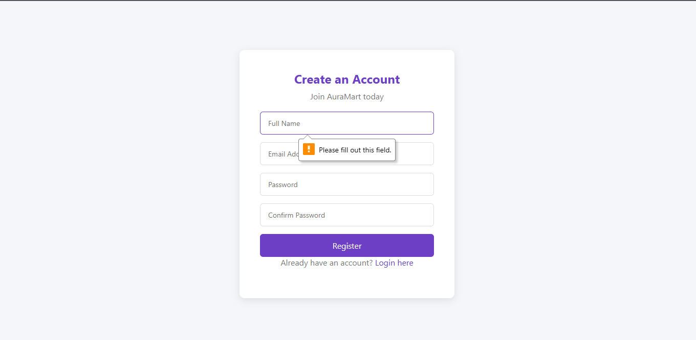

Figure 3.4: PHP database connection script (includes/db.php) showing a successful connection to the auramart MySQL database using mysqli_connect(), with a confirmation message displayed in the browser.
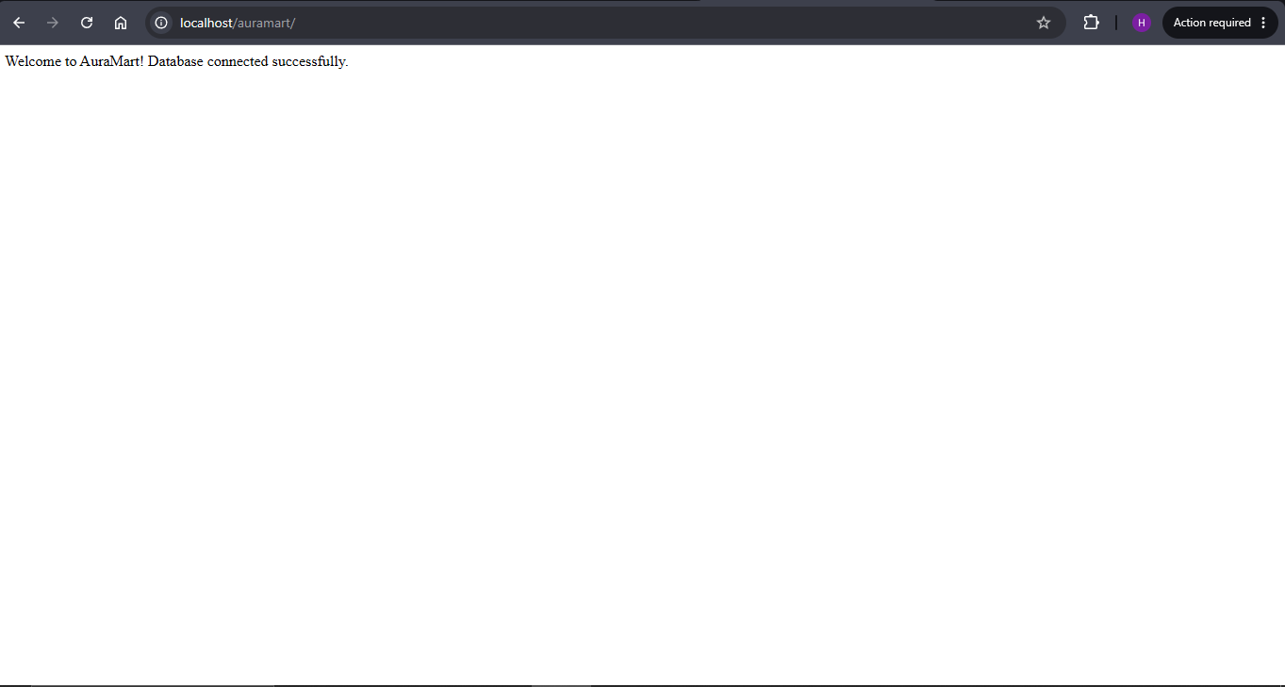

Figure 3.5: Completed AuraMart registration form in the browser showing all input fields rendered correctly, followed by a phpMyAdmin screenshot confirming the new user record was saved with a hashed password.
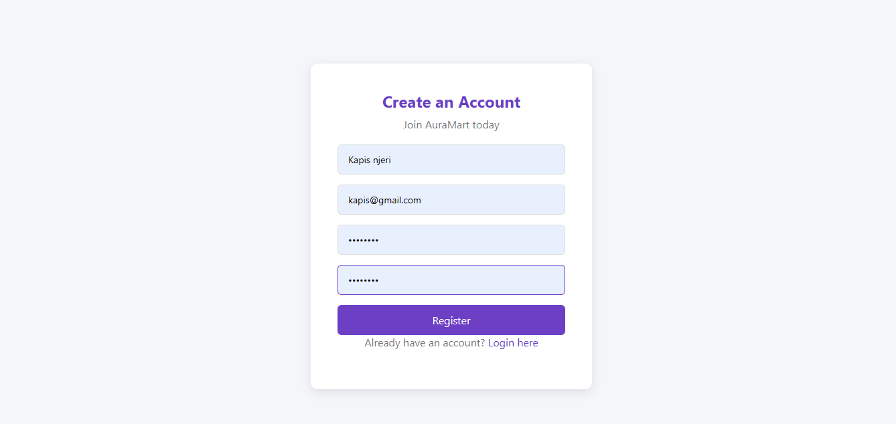
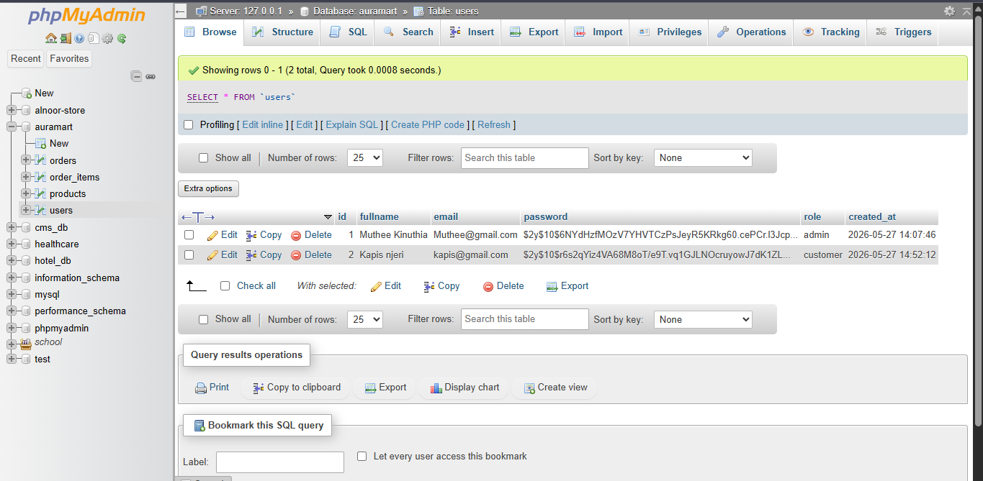

3.4 Code Sample
JavaScript — Registration Form Validation (js/main.js)

function validateRegister() {
const fullname = document.getElementById('fullname').value.trim();
const password = document.getElementById('password').value;
const confirm = document.getElementById('confirm_password').value;

if (fullname === '') {
alert('Please enter your full name.');
return false;
}
if (password.length < 6) {
alert('Password must be at least 6 characters.');
return false;
}
if (password !== confirm) {
alert('Passwords do not match.');
return false;
}
return true;
}

3.5 Objectives Completed

- JavaScript variables, functions, and events implemented in js/main.js
- Registration form validation
- Login form validation.
- DOM manipulation implemented using getElementById() to read input values
- PHP syntax practiced using echo, variables, and conditional statements
- Registration and login form processors
- Database connection established in includes/db.php
- Passwords stored securely using PHP password_hash() function
- GitHub repository updated with Week 3 progress

3.6 Reflection

This week I implemented JavaScript form validation and PHP backend processing for the AuraMart authentication system. Figure 3.1 demonstrates the JavaScript alert preventing empty form submission, showing that client side validation starts before any data is sent to the server. On the backend, PHP was used to receive form data, sanitise it, and store passwords securely. Figure 3.4 confirms a successful database connection, linking the PHP backend to the database.

WEEK 4: SERVER-SIDE COMPONENTS AND BACKEND DEVELOPMENT

4.1 Objective
To build a complete server-side authentication system using PHP sessions, role-based access control, and a professional project folder structure. The system enables users to log in, maintain authenticated sessions, and be redirected to role-appropriate pages upon login.

4.2 Key Concepts Implemented

Concept | Application in AuraMart | File
session_start() | Called on every protected page to initialise and verify the user session | All protected pages
$_SESSION variables | Stores user ID, full name, and role after successful login for use across pages | login.php, dashboard.php
password_verify() | Compares the submitted password against the stored hash to authenticate the user | login.php
Role-Based Redirect | Admins redirected to admin/index.php; customers redirected to dashboard.php | login.php
Session Destroy | session_destroy() called in logout.php to clear all session data on logout | logout.php
GET Method | Used for delete actions to pass IDs through the URL | admin/products.php
POST Method | Used for all sensitive form submissions including login and registration | login.php, register.php
Folder Structure | Project organised into css/, js/, includes/, admin/, images/, and database/ | Project root

4.3 Evidence

Figure 4.1: AuraMart login form displayed in the browser showing the email and password input fields with the login button, ready to authenticate users.
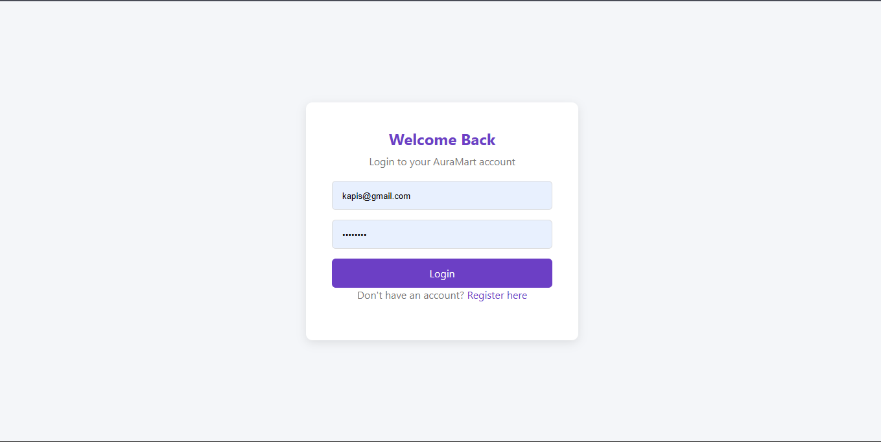

Figure 4.2: JavaScript validation alert on the login form triggered when the email field is submitted empty, demonstrating client-side checks before server processing.
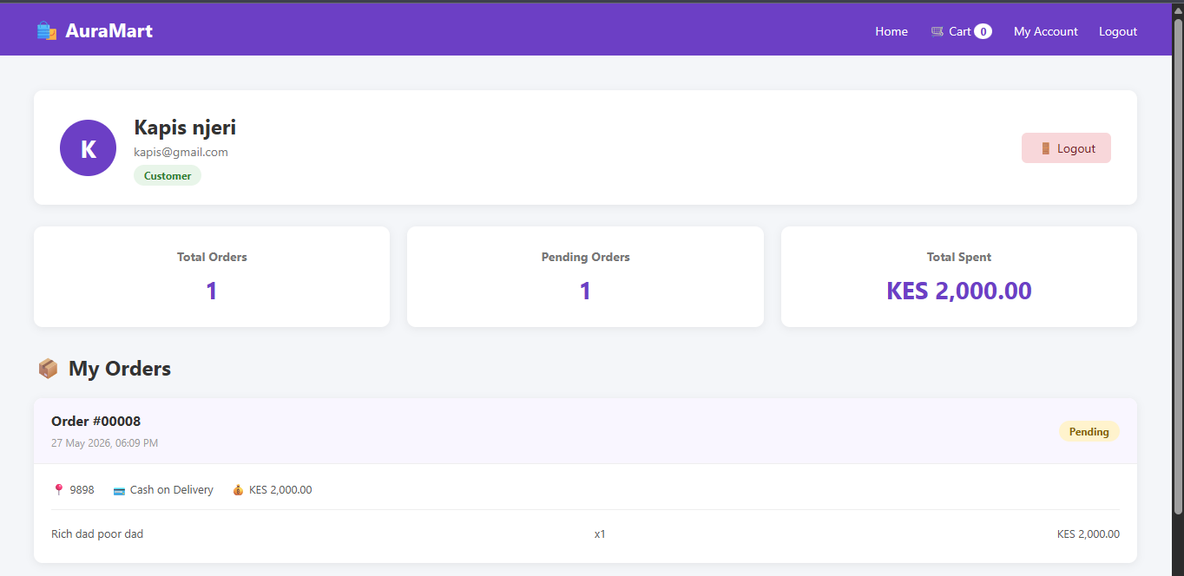

Figure 4.4: AuraMart project folder structure displayed in VS Code Explorer showing the organised directory layout including css/, js/, includes/, admin/, images/, and database/ folders.
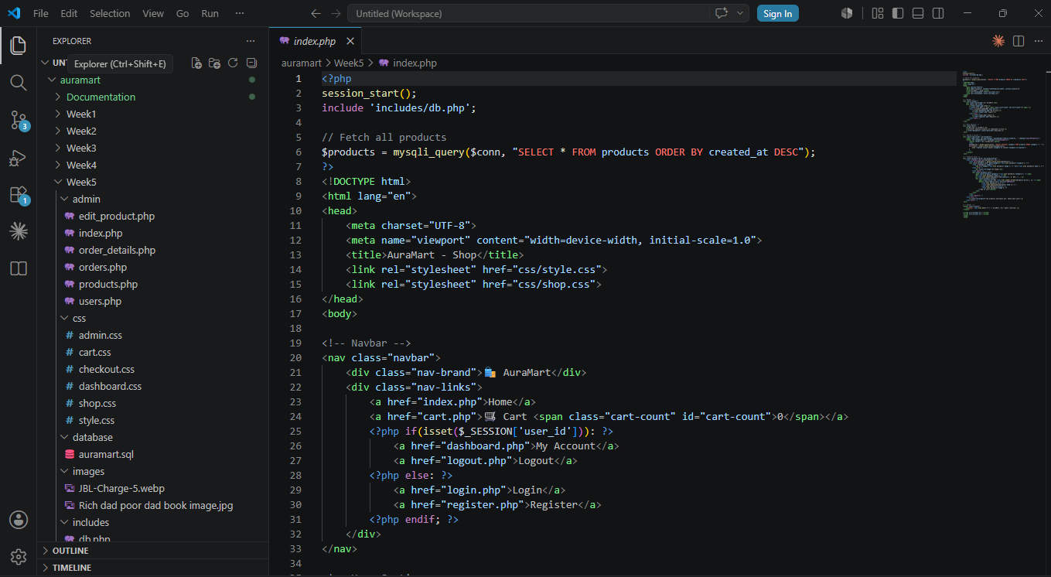
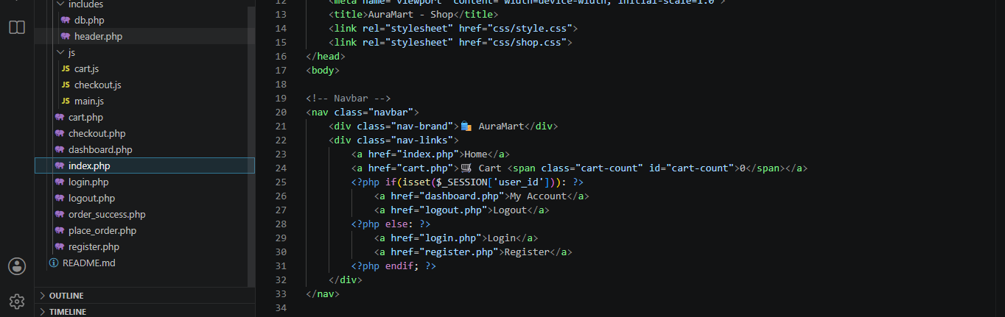

Figure 4.5: phpMyAdmin users table showing a registered user record with the password column containing a hash generated by PHP , confirming no plain text passwords are stored.


4.4 Code Sample
PHP — Session-Based Login with Role Redirect (login.php)

<?php
session_start();
include 'includes/db.php';

if(isset($_POST['login'])){
$email = mysqli_real_escape_string($conn, $_POST['email']);
$password = $_POST['password'];
$result = mysqli_query($conn, "SELECT * FROM users WHERE email='$email'");

if(mysqli_num_rows($result) == 1){
$user = mysqli_fetch_assoc($result);
if(password_verify($password, $user['password'])){
$_SESSION['user_id'] = $user['id'];
$_SESSION['user_name'] = $user['fullname'];
$_SESSION['user_role'] = $user['role'];
if($user['role'] == 'admin'){
header('Location: admin/index.php');
} else {
header('Location: dashboard.php');
}
}
}
}
?>

4.5 Objectives Completed

- Login and registration forms created with full frontend and backend integration
- PHP $_POST used to receive and process all form submissions securely
- session_start() implemented on all protected pages requiring authentication
- $_SESSION variables storing user ID, name, and role after successful login
- Role-based redirect implemented admin to admin panel, customer to dashboard
- password_verify() used to authenticate users against stored hashed passwords
- logout.php created to destroy the session and redirect to the login page
- Professional project folder structure organised and committed to GitHub
- GitHub repository updated with Week 4 progress

4.6 Reflection

I completed the full authentication system using PHP sessions and role-based access control. Figure 4.3 confirms the session-based dashboard correctly displays the logged-in user's name, retrieved after successful authentication. The role-based redirect in login.php directs admin users to the admin panel while customers are sent to their personal dashboard, ensuring each user type sees only their relevant interface. Figure 4.5 demonstrates that passwords are stored as bcrypt hashes, confirming no plain text passwords exist in the database.

WEEK 5: DATABASE COMPONENTS AND CRUD OPERATIONS

5.1 Objective
To complete the database driven architecture of the platform by implementing full CRUD operations across all levels including products, orders, users, and order items and integrating these with both the admin panel and customer-facing storefront.

5.2 Database Schema
The database comprises four normalised tables with foreign key relationships to maintain data integrity across the system.

Table | Primary Key | Foreign Key | Purpose
users | id (AUTO_INCREMENT) | None | Stores customer and admin account records
products | id (AUTO_INCREMENT) | None | Stores the product catalogue data
orders | id (AUTO_INCREMENT) | user_id → users | Records customer order transactions
order_items | id (AUTO_INCREMENT) | order_id, product_id | Stores individual line items per order

5.3 CRUD Operations

Operation | SQL | Use Case in AuraMart | File
CREATE | INSERT INTO | Add product, register user, place order | register.php, admin/products.php, place_order.php
READ | SELECT * | Display products, list orders, view users | index.php, admin/orders.php, admin/users.php
UPDATE | UPDATE SET | Edit product, update order status, change user role | admin/edit_product.php, admin/orders.php
DELETE | DELETE FROM | Remove product or delete user account | admin/products.php, admin/users.php

5.4 Evidence

Figure 5.1: phpMyAdmin interface displaying the AuraMart database with all four tables listed: users, products, orders, and order_items, confirming the complete normalised schema.
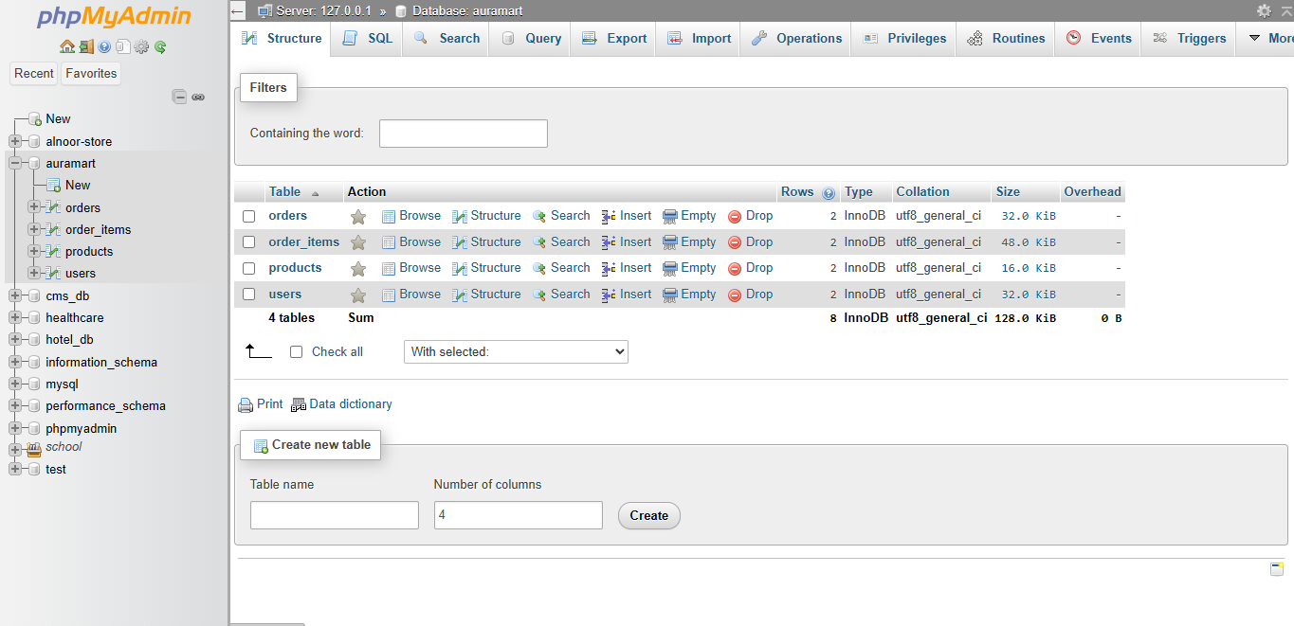

Figure 5.2: phpMyAdmin showing the products table structure with all columns: id, name, description, price, stock, category, image, and created_at, created using the SQL CREATE TABLE statement.
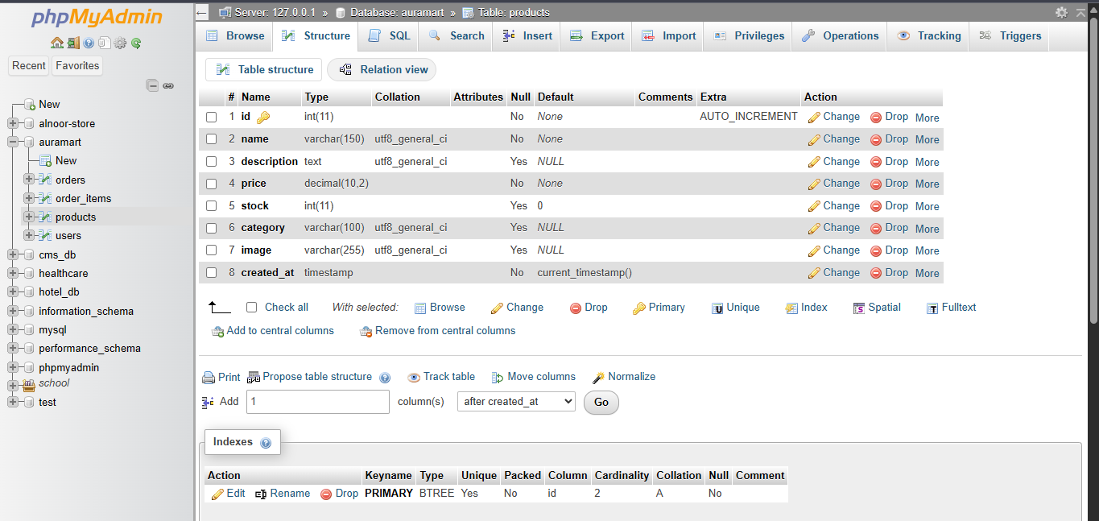

Figure 5.3: Admin products management page showing the Add Product form and the product listing table with at least two products including name, category, price, stock, and action buttons.
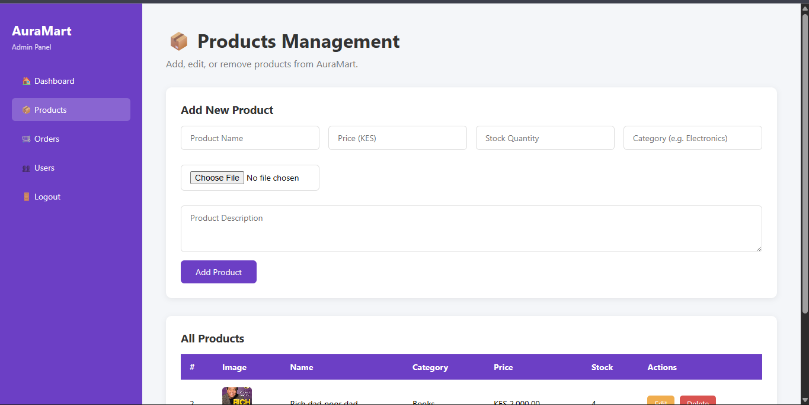

Figure 5.4: phpMyAdmin orders table showing a completed order record with fields: user_id, fullname, email, phone, address, total, payment_method, status, and created_at populated after a successful checkout.
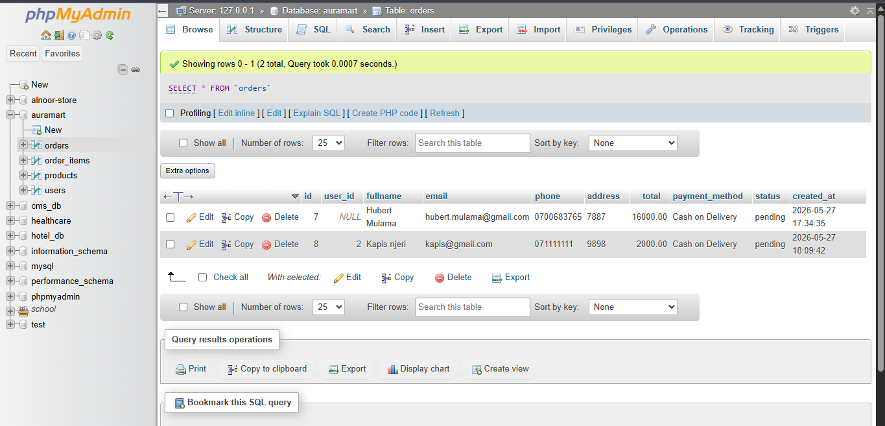

Figure 5.5: Admin orders management page displaying the orders list with colour-coded status badges (Pending, Processing, Shipped, Delivered, Cancelled) and the Update Status dropdown for each order.
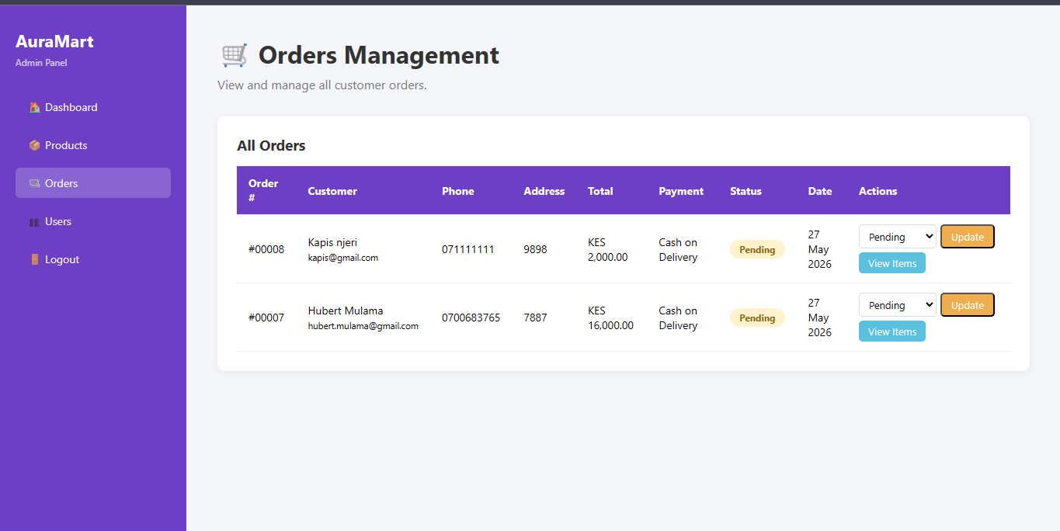

5.5 Code Sample
Creating the Products Table

CREATE TABLE products (
id INT PRIMARY KEY AUTO_INCREMENT,
name VARCHAR(150) NOT NULL,
description TEXT,
price DECIMAL(10,2) NOT NULL,
stock INT DEFAULT 0,
category VARCHAR(100),
image VARCHAR(255),
created_at TIMESTAMP DEFAULT CURRENT_TIMESTAMP
);

PHP — Dynamically Fetching Products from Database (index.php)

<?php
$products = mysqli_query($conn, 'SELECT * FROM products ORDER BY created_at DESC');

while($product = mysqli_fetch_assoc($products)){
echo '<div class="product-card">';
echo '<h3>' . $product['name'] . '</h3>';
echo '<p>KES ' . number_format($product['price'], 2) . '</p>';
echo '</div>';
}
?>

5.6 Objectives Completed

- AuraMart database created with four normalised tables: users, products, orders, order_items
- Foreign key constraints established: orders → users and order_items → orders/products
- CREATE new products added via admin panel and saved to the MySQL database
- READ product catalogue fetched and rendered on the homepage
- UPDATE product details editable through the admin edit product form
- DELETE products and users removable from the admin panel with confirmation
- Orders and order items tables populated when customers complete checkout
- Product stock automatically decremented when an order is placed
- Admin dashboard updated to show live statistics: products, orders, users, and revenue
- Database exported as auramart.sql and pushed to the GitHub repository
- Weekly folder structure uploaded to GitHub with documentation

5.7 Reflection

I completed the full database integration, implementing all four CRUD operations across products, orders, users, and order items. Figure 5.1 shows the normalised database schema with four tables and their relationships in phpMyAdmin. The admin panel fetches and displays all records using SELECT queries, while INSERT is used when new products are added or customers complete checkout. Figure 5.4 confirms that order records are correctly persisted to the database with all customer and payment details intact.

